**SATYAM GARG**

**500095032**

**WEB ANALYTICS**

**ASSIGNMENT TOPIC- Google sites analysis using Google Analytics**

1. **Realtime users-**
2. **Users in last 30 minutes-** Users in last 30 minutes shows the 5 web pages and app screens with the most users in the past 30 minutes.

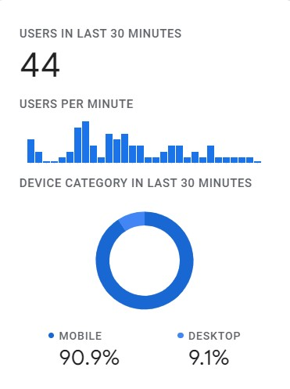

1. **Real time map report –**  It shows the real time map of the last 30 minute users.

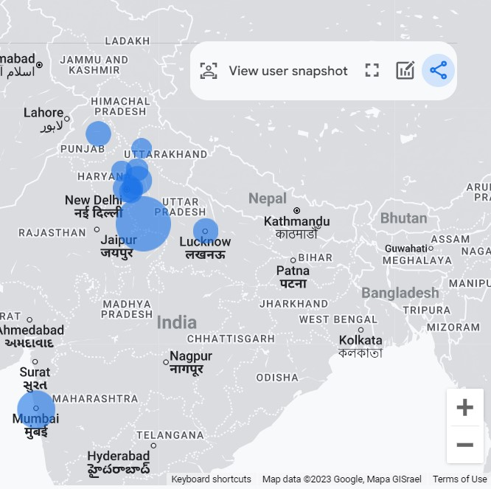

**2) Home page overview-**

* **USERS-**  A user is a unique or new visitor to the website.
* **VIEWS-** Total number of pages viewed.
* **EVENT COUNTS-** Total no of times website was scroll and clicked.
* **SESSIONS-**  The group of visitor interactions that happen in a 30-minute window of activity.

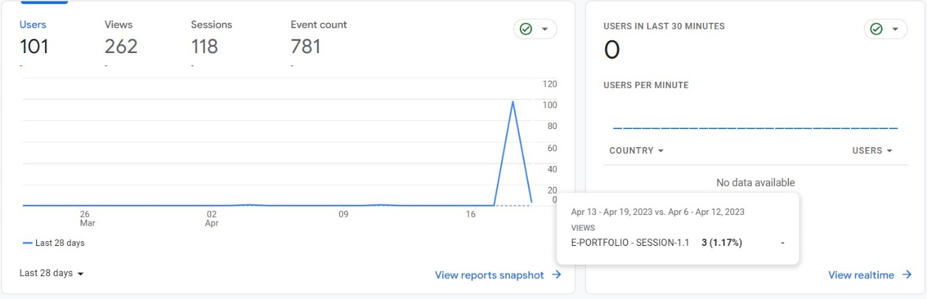

# 3)User acquisition- **User acquisition data** provides insight into how customers are arriving at the website. Customers may come from a variety of channels, such as paid search engine results, unpaid search engine results, social media links or simply typing in the URL.

# 

# 4) Traffic acquisition- Traffic acquisition report to get insights into where new sessions came from, regardless of whether the user is new or returning.

# 

**5) Event count by Event name**- Event count by Event name shows the number of times users triggered each [event](https://support.google.com/analytics/answer/9322688) in the specified time frame, sorted by the most frequently triggered event.

For example, in the following table, the page_view and scroll events were the most frequently triggered events.

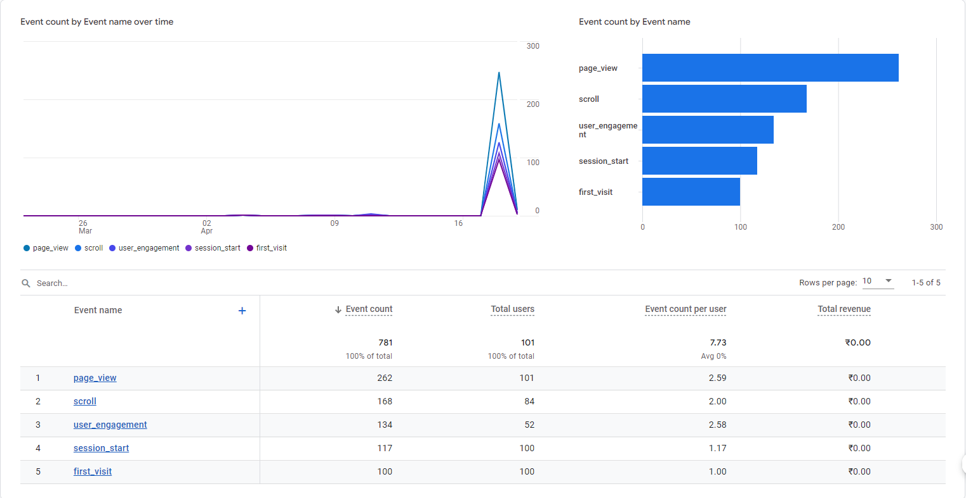

**6) Conversions**-Conversions by Event name shows the number of times users trigger each conversion event. While Analytics automatically collects some events as conversions, you can [mark any event as a conversion event](https://support.google.com/analytics/answer/9267568).

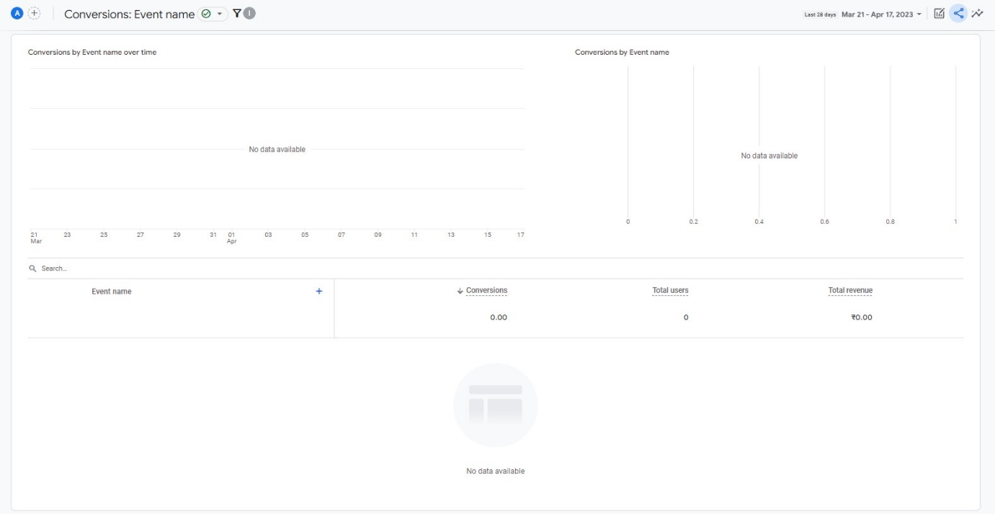

**7) Views by Page title and screen class-** Views by Page title and screen class shows the number of times users viewed each page or screen in the specified time frame, sorted by the most frequently viewed pages and screens.

For example, in the following table, the E-PORTFOLIO page is the most frequently viewed pages.

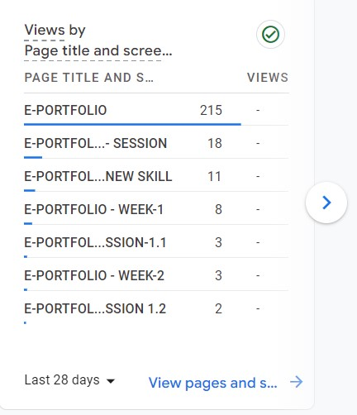

# 8) Monetization overview- Data monetization is the process where company-generated data is used to create a measurable economic benefit.

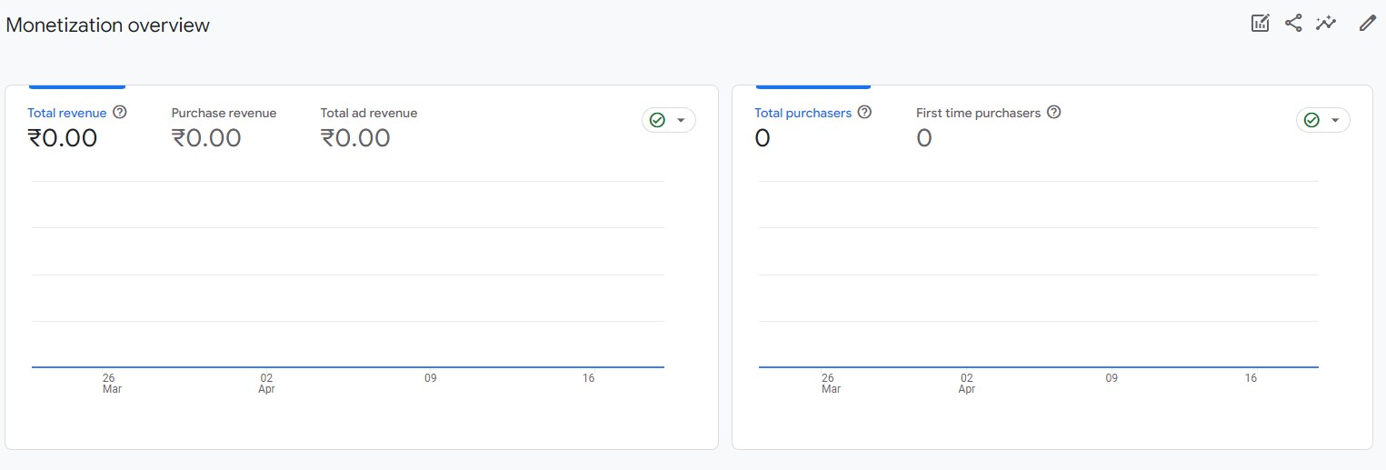

# 9) Tech overview- The Tech overview report in Google Analytics displays your app or website traffic by your visitor's technology, such as platform, operating system, screen resolution, and app version.

# 

# 10) Demographics overview- Demographics and interests data provides information about the age and gender of your users, along with the interests they express through their online travel and purchasing activities.

# 

## **11) User retention-**User retention shows the percentage of users who return each day in their first 42 days. The chart starts with 100% user retention when all users visit for the first time. It decreases from the first day as users drop off.

